National Economics University
Faculty of Mathematical Economics



BACHELOR THESIS
TOPIC: The Causal Effect of Policy Sales Channel Assignment on Customer Response: Evidence from Insurance Cross-Selling

Student : Phùng Minh Hằng
Student’s ID : 11222120
Specialized : Actuarial Science
Supervisor : MSc. Nguyen Quoc Thanh

Hanoi, May 2026

ACKNOWLEDGEMENTS
I would like to express my sincere gratitude to my supervisor, Nguyen Quoc Thanh, for his guidance, feedback, and encouragement throughout the development of this thesis. The comments on causal identification, counterfactual interpretation, diagnostic checks, and treatment effect heterogeneity helped improve the research design substantially.
I also thank the lecturers of the program for providing the analytical and methodological foundation needed to complete this research.

EXECUTIVE SUMMARY
This thesis examines whether policy sales channel assignment affects customer response in an insurance cross-selling setting. Using the Health Insurance Cross Sell dataset, the study focuses on two major coded policy sales channels: channel 26 and channel 124. Channel 26 is defined as the treatment group, while channel 124 is used as the control group. The outcome is customer response to a vehicle insurance offer.
The central counterfactual question is: for a customer in the analysis sample, how would the probability of response change if the customer were assigned to channel 26 instead of channel 124? This framing shifts the problem from a pure prediction task to a causal inference task. The main estimand is the Average Treatment Effect (ATE). Propensity Score Matching (PSM) is used as a supporting ATT-based comparison, while causal forest is used to estimate heterogeneous treatment effects and support targeting analysis.
The empirical strategy adjusts for observed pre-treatment covariates, including gender, age, region code, previously insured status, vehicle age, vehicle damage, log annual premium, and vintage. The causal design is supported by a directed acyclic graph (DAG) and a formal dagitty adjustment check. The DAG-based check is used to verify whether the selected covariates satisfy the back-door criterion under the specified causal graph. However, the thesis also acknowledges that unobserved confounding may remain because the dataset is observational.
The main AIPW estimate indicates that assignment to channel 26 rather than channel 124 is associated with an increase in response probability of approximately 2.64 percentage points, under the selection-on-observables assumption. IPW and causal forest estimates are close to the AIPW estimate. Robustness diagnostics, including trimmed AIPW and a negative-control outcome diagnostic, support the stability of the empirical pipeline. Causal forest diagnostics, RATE/Qini results, and targeting analysis suggest that customers originally assigned to channel 124 can be ranked by predicted incremental gain if assigned to channel 26.
The thesis concludes that policy sales channel assignment may have meaningful implications for insurance cross-selling, but the findings should be interpreted cautiously due to the observational nature of the dataset and possible hidden confounding.

ABBREVIATIONS
Abbreviation | Meaning
AIPW | Augmented Inverse Probability Weighting
ATE | Average Treatment Effect
ATT | Average Treatment Effect on the Treated
CATE | Conditional Average Treatment Effect
CI | Confidence Interval
DAG | Directed Acyclic Graph
HTE | Heterogeneous Treatment Effect
IPW | Inverse Probability Weighting
LPM | Linear Probability Model
PSM | Propensity Score Matching
RATE | Rank Average Treatment Effect
SMD | Standardized Mean Difference
SUTVA | Stable Unit Treatment Value Assumption

Table of Contents
ACKNOWLEDGEMENTS 2
EXECUTIVE SUMMARY 3
ABBREVIATIONS 4
CHAPTER 1. INTRODUCTION 7
1.1. Background of the Study 7
1.2. Research Problem 8
1.3. Research Objectives and Questions 8
1.4. Scope and Contributions 9
1.5. Thesis Structure 10
CHAPTER 2. THEORETICAL BACKGROUND 11
2.1. Insurance Cross-Selling and Sales Channel Effectiveness 11
2.2. Prediction versus Causal Inference 12
2.3. Potential Outcomes and Confounding 12
2.4. Propensity Score, AIPW and Causal Forest 13
2.5. Summary 14
CHAPTER 3. DATA AND CAUSAL RESEARCH DESIGN 15
3.1. Data Source and Sample Construction 15
3.2. Variable Definition 19
3.3. Descriptive Statistics and Baseline Differences 21
3.4. Causal Research Design and DAG Check 25
CHAPTER 4. METHODOLOGY 30
4.1. Empirical Strategy and Estimands 30
4.2. Identification Assumptions 31
4.3. Benchmark and Propensity Score Model 33
4.4. Treatment Effect Estimators 34
4.5. Diagnostics and Heterogeneity Methods 36
CHAPTER 5. EMPIRICAL RESULTS AND DISCUSSION 38
5.1. Descriptive Results and Baseline Imbalance 38
5.2. Propensity Score and Overlap Diagnostics 40
5.3. Main Causal Estimates 43
5.4. Robustness and Diagnostic Checks 45
5.5. Causal Forest and Heterogeneity Analysis 48
5.6. Targeting Analysis among Channel 124 Customers 51
5.7. Discussion 54
CHAPTER 6. CONCLUSION 56
6.1. Summary of Main Findings 56
6.2. Managerial Implications 56
6.3. Limitations 57
6.4. Future Research Directions 57
REFERENCES 59
APPENDICES 60
Appendix A. Suggested figures to insert from R 60
Appendix B. Notes on interpretation 60

CHAPTER 1. INTRODUCTION

1.1. Background of the Study
In the insurance industry, cross-selling is an important strategy for increasing customer value and improving marketing efficiency. Instead of focusing only on acquiring new customers, insurance firms can offer additional products to customers who already have an existing relationship with the firm. A customer who has previously interacted with one insurance product may also have potential demand for another related product, such as vehicle insurance. In this context, customer response to a cross-selling offer becomes an important indicator of campaign performance.
A common approach to insurance cross-selling is customer response prediction. Predictive models are useful because they help firms identify customers who are more likely to respond to an offer. However, prediction alone does not answer a more intervention-oriented managerial question: would the same customer respond differently if the firm used another policy sales channel? This distinction matters because a customer with a high response probability may respond regardless of the channel used, while another customer may respond only when reached through a more suitable channel.
Sales channel allocation is a business decision that can potentially be changed. Different policy sales channels may differ in communication quality, trust, convenience, product explanation, and ability to persuade customers. Therefore, a sales channel may not only be associated with customer response, but may also affect it. For an insurance firm, the relevant question is not only which customers are likely to respond, but also which channel can create additional response.
This thesis applies a causal inference framework to examine the effect of policy sales channel assignment on customer response in an insurance cross-selling setting. Using the Health Insurance Cross Sell dataset, the study focuses on customers assigned to policy sales channel 26 and policy sales channel 124. Channel 26 is defined as the treatment group, while channel 124 is used as the control group. The outcome of interest is whether the customer responds positively to the vehicle insurance offer.
The central counterfactual question of this thesis is: for a customer in the analysis sample, how would the probability of response change if the customer were assigned to channel 26 instead of channel 124? This question shifts the study from pure prediction to causal analysis.

1.2. Research Problem
Although customer response prediction is useful, it is not sufficient for evaluating sales channel effectiveness. A predictive model can estimate which customers are likely to respond, but it cannot determine whether assigning a customer to a particular channel actually changes the probability of response. This is a limitation when the business objective is to evaluate or improve channel allocation.
The main challenge is that the dataset used in this thesis is observational. Customers were not randomly assigned to policy sales channels. Therefore, customers in channel 26 and channel 124 may have different characteristics before response is observed. For example, age, region, previous insurance status, vehicle age, vehicle damage, annual premium, and vintage may influence both channel assignment and customer response.
Because of this non-random assignment, the raw difference in response rates between channel 26 and channel 124 cannot be interpreted directly as a causal effect. The observed difference may reflect the effect of the channel, but it may also reflect differences in customer composition. A simple comparison of response rates may therefore be biased.
The research problem of this thesis is how to estimate the effect of policy sales channel assignment on customer response using observational insurance data while adjusting for observed confounding factors. The study addresses this problem using propensity score methods, doubly robust estimation, diagnostic checks, and causal forest analysis.
At the same time, the study acknowledges that the data are not generated from a randomized experiment. The policy sales channel variable is a coded category in a public dataset, and the exact business logic behind channel assignment is not observed. Therefore, the results should be interpreted under the selection-on-observables assumption rather than as evidence equivalent to a randomized controlled trial.

1.3. Research Objectives and Questions
The general objective of this thesis is to estimate the effect of policy sales channel assignment on customer response in a vehicle insurance cross-selling context. Specifically, the study examines whether customers assigned to policy sales channel 26 have a different probability of responding positively compared with customers assigned to policy sales channel 124, after adjusting for observed pre-treatment customer characteristics.
The specific objectives are:
- To define the treatment, outcome, analysis sample, and adjustment variables.
- To examine baseline differences and overlap between customers in channel 26 and channel 124.
- To estimate the average treatment effect using IPW and AIPW, with AIPW as the main estimator.
- To use PSM as a supporting ATT-based comparison.
- To evaluate robustness using common support trimming, a negative-control outcome diagnostic, and a permutation-based pipeline sanity check.
- To explore heterogeneous treatment effects using causal forest.
- To examine whether customers originally assigned to channel 124 can be ranked by predicted incremental gain if assigned to channel 26.
This thesis addresses three research questions.
First, what is the estimated average effect of assignment to policy sales channel 26 rather than channel 124 on customer response, after adjusting for observed pre-treatment customer characteristics? The main estimand is the Average Treatment Effect:
$$ATE=E\left[Y_{i}\left(1\right)-Y_{i}\left(0\right)\right]$$
Second, are the estimated effects consistent across different causal inference methods and diagnostic checks?
Third, does the effect of policy sales channel assignment differ across customer segments, and which customers originally assigned to channel 124 may have the highest predicted gain if assigned to channel 26?

1.4. Scope and Contributions
This thesis uses the Health Insurance Cross Sell dataset, in which each observation represents one customer. The study focuses only on customers assigned to policy sales channel 26 and policy sales channel 124. This restriction allows the study to define a clear binary treatment variable and apply standard causal inference methods.
The treatment is assignment to channel 26. The control condition is assignment to channel 124. The outcome is customer response, coded as 1 if the customer responds positively and 0 otherwise. The analysis adjusts for observed pre-treatment covariates, including gender, age, region code, previously insured status, vehicle age, vehicle damage, log annual premium, and vintage.
The thesis contributes to the literature and practice in three ways. First, it applies causal inference to the problem of insurance cross-selling, shifting the focus from pure prediction to intervention-oriented evaluation. Second, it combines multiple causal tools, including DAG-based adjustment, propensity score methods, AIPW, negative-control diagnostics, and causal forest. Third, it extends the analysis from average treatment effects to heterogeneous treatment effects and targeting analysis among customers originally assigned to channel 124.

1.5. Thesis Structure
The thesis is organized as follows.
Chapter 2 reviews the theoretical background for insurance cross-selling, causal inference, propensity score methods, AIPW and causal forest.
Chapter 3 presents the data description and causal research design, including the dataset, treatment definition, analysis sample, pre-treatment covariates, DAG check and identification assumptions.
Chapter 4 presents the methodology and formal estimators.
Chapter 5 reports the empirical results and discussion.
Chapter 6 concludes the thesis by summarizing the main findings, managerial implications, limitations, and future research directions.

CHAPTER 2. THEORETICAL BACKGROUND

2.1. Insurance Cross-Selling and Sales Channel Effectiveness
Cross-selling refers to the practice of offering additional products or services to existing customers. In insurance and financial services, cross-selling is important because firms already have some information about their customers, such as demographic characteristics, product ownership, and previous interactions. Compared with acquiring new customers, cross-selling can be more efficient because the firm does not need to build the customer relationship from the beginning.
In the insurance industry, customers often have multiple protection needs. A customer who already has one insurance product may also be interested in another product if the offer is relevant to their risk profile, vehicle ownership, financial situation, or personal characteristics. Therefore, customer response to cross-selling offers is an important outcome for evaluating marketing effectiveness.
Sales channels are central to insurance distribution. They determine how insurance products are introduced, communicated, and delivered to customers. In practice, insurance products may be distributed through agents, brokers, direct channels, digital platforms, bancassurance, or other internal sales channels. Each channel may differ in customer access, communication quality, trust, cost, and ability to persuade customers.
A sales channel may affect customer response through several mechanisms. First, different channels may provide different levels of product explanation. Insurance products can be complex, and customers may require information before deciding whether to respond. Second, some channels may generate more trust than others. Third, channels may differ in convenience and transaction cost. Finally, some channels may be better suited to particular customer segments.
However, evaluating sales channel effectiveness using observational data is difficult. Customers are usually not randomly assigned to channels. Firms may allocate customers to channels based on customer profile, region, campaign rules, agent availability, or predicted sales potential. Therefore, customers in different channels may differ before the offer is observed. If these pre-existing differences also affect customer response, a simple comparison of response rates between channels may be confounded.

2.2. Prediction versus Causal Inference
Prediction and causal inference answer different types of questions. Prediction asks what is likely to happen. In customer response modeling, the predictive question is: which customers are more likely to respond to an insurance offer? The main objective of predictive modeling is accuracy.
Causal inference asks what would happen if an intervention were changed. In this thesis, the causal question is: how would a customer’s probability of response change if the customer were assigned to channel 26 instead of channel 124? This question is counterfactual because it compares two possible treatment states for the same customer.
The associational comparison is:
$$P\left(Y_{i}=1∣T_{i}=1\right)-P\left(Y_{i}=1∣T_{i}=0\right)$$
The causal comparison is:
$$P\left(Y_{i}=1∣do\left(T_{i}=1\right)\right)-P\left(Y_{i}=1∣do\left(T_{i}=0\right)\right)$$
The first expression compares observed outcomes between customers in different channels. The second expression represents an intervention: assigning customers to one channel rather than another. These two quantities are not necessarily the same in observational data because treatment assignment may be confounded.
This distinction is central to the thesis. A high response rate in channel 26 does not automatically imply that channel 26 causes higher response. The difference may be driven by customer characteristics. Therefore, the thesis uses causal inference methods to adjust for observed pre-treatment covariates and estimate treatment effects under explicit assumptions.

2.3. Potential Outcomes and Confounding
The potential outcomes framework provides a formal language for defining causal effects. For each customer (i), there are two potential outcomes. (Y_i(1)) is the potential response outcome if the customer is assigned to channel 26, and (Y_i(0)) is the potential response outcome if the same customer is assigned to channel 124.
The individual treatment effect is:
$$τ_{i}=Y_{i}\left(1\right)-Y_{i}\left(0\right)$$
However, the individual treatment effect cannot be directly observed because each customer can only be observed under one treatment condition. This is the fundamental problem of causal inference. For this reason, the thesis focuses on average and conditional treatment effects.
The Average Treatment Effect is:
$$ATE=E\left[Y_{i}\left(1\right)-Y_{i}\left(0\right)\right]$$
The Average Treatment Effect on the Treated is:
$$ATT=E\left[Y_{i}\left(1\right)-Y_{i}\left(0\right)∣T_{i}=1\right]$$
The Conditional Average Treatment Effect is:
$$CATE\left(X_{i}\right)=E\left[Y_{i}\left(1\right)-Y_{i}\left(0\right)∣X_{i}\right]$$
In this thesis, ATE is the main estimand, ATT is used for PSM as a supporting estimate, and CATE is used for heterogeneity and targeting analysis.
Confounding occurs when a variable affects both treatment assignment and the outcome. In this study, customer characteristics such as age, region, previous insurance status, vehicle age, vehicle damage, annual premium, and vintage may influence both policy sales channel assignment and customer response. These variables may create back-door paths between treatment and outcome.
A simplified confounding structure can be written as:
$$X_{i}→T_{i}, X_{i}→Y_{i}$$
DAGs are useful because they make causal assumptions explicit. In this thesis, the DAG is used as a formal identification device and checked through the back-door criterion. Nevertheless, DAG-based checking does not prove that the specified DAG is the true data-generating process.

2.4. Propensity Score, AIPW and Causal Forest
Propensity score methods are commonly used in observational studies to adjust for observed differences between treatment and control groups. The propensity score represents the probability of receiving treatment conditional on observed covariates.
The propensity score is defined as:
$$e\left(X_{i}\right)=P\left(T_{i}=1∣X_{i}\right)$$
In this thesis, (e(X_i)) is the probability that customer (i) is assigned to channel 26 given observed customer characteristics. Propensity scores can be used for matching, weighting, and overlap diagnostics. PSM compares treated customers with similar control customers, while IPW uses propensity scores to reweight observations and create a more balanced pseudo-population.
Average treatment effects summarize the overall effect of a treatment, but they may hide important differences across customer segments. Therefore, this thesis also considers heterogeneous treatment effects using causal forest. Causal forest estimates how the effect of channel 26 relative to channel 124 varies with customer characteristics.

2.5. Summary
This chapter reviewed the theoretical background for the empirical analysis. Insurance cross-selling is introduced as a marketing problem in which customer response is a key outcome. The discussion then distinguishes predictive modeling from causal inference. While prediction asks which customers are likely to respond, causal inference asks whether changing the sales channel would change response probability.
The potential outcomes framework defines the causal estimands used in the thesis, especially ATE, ATT, and CATE. DAGs are used to make identification assumptions explicit and to justify the observed adjustment set. Propensity score methods, doubly robust estimation, and causal forest provide the methodological foundation for estimating average and heterogeneous treatment effects. The next chapter presents the detailed methodology, including formal estimators, robustness diagnostics, and targeting metri

CHAPTER 3. DATA AND CAUSAL RESEARCH DESIGN

3.1. Data Source and Sample Construction

3.1.1. Dataset overview
This thesis uses the Health Insurance Cross Sell Prediction dataset from Kaggle. The dataset contains customer-level information related to a vehicle insurance cross-selling campaign. Each observation represents one customer, and the main outcome is whether the customer responded positively to a vehicle insurance offer.
The original dataset contains 381,109 observations and 12 variables. These variables include customer demographic characteristics, insurance history, vehicle-related information, annual premium, policy sales channel, customer vintage, and response outcome. The response variable is binary, where 1 indicates that the customer responded positively and 0 indicates no response.
The dataset is suitable for this thesis because it contains both a response outcome and a policy sales channel variable. However, because the dataset is observational, policy sales channel assignment should not be interpreted as randomized assignment. In the full dataset, the overall response rate is approximately 12.26%. No missing values are detected in the main variables used in the analysis.
Table 3.1. Original dataset overview
Item | Value
Number of observations | 381,109
Number of variables | 12
Missing values in main variables | 0
Response cases | 46,710
Non-response cases | 334,399
Overall response rate | 12.26%
Source: Calculation from the Health Insurance Cross Sell dataset.
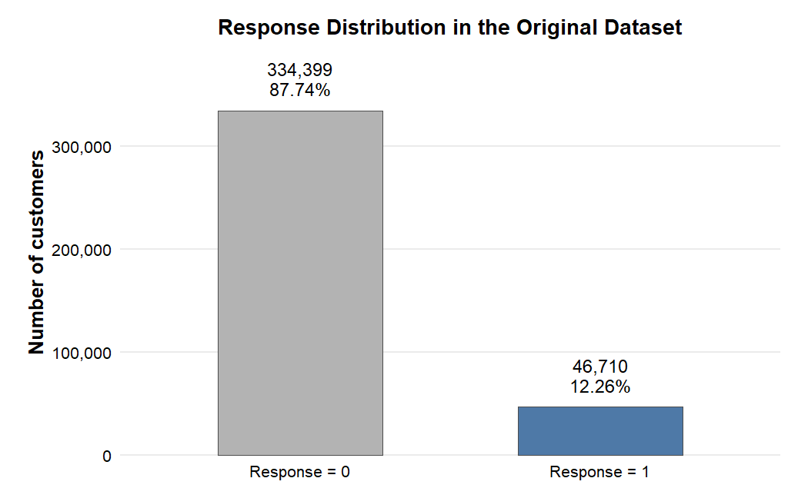Figure 3.1. Response distribution in the original dataset
Source: Calculation from the original dataset.
This figure shows the imbalance of the response outcome in the original dataset. The dominance of non-response cases motivates careful interpretation of customer response and provides initial context for the empirical analysis.
The variable Policy_Sales_Channel contains multiple coded channel categories. Since the dataset does not provide detailed business descriptions of each channel code, this thesis does not assign specific business names to the channels. Instead, channel 26 and channel 124 are treated as two observed policy sales channel categories in the public dataset.

3.1.2. Treatment selection
The original dataset includes many policy sales channels. If all channels were used as a multi-treatment setting, the research design would become more complex and difficult to interpret within the scope of this thesis. Therefore, the study simplifies the setting into a binary treatment comparison.
This thesis focuses on policy sales channel 26 and policy sales channel 124. These two channels are selected because both have large sample sizes, relatively balanced group sizes, and sufficiently comparable response rates. This makes the comparison suitable for estimating the effect of one channel relative to another.
Customers assigned to channel 26 are defined as the treated group. Customers assigned to channel 124 are defined as the control group. This design allows the study to estimate the effect of being assigned to channel 26 rather than channel 124.
The choice of a two-channel design is also motivated by interpretability. In a multi-channel setting, each channel would represent a separate treatment condition, and the estimand would no longer be a simple comparison between two potential outcomes. Such a design may require multinomial treatment models, generalized propensity scores, or pairwise causal comparisons. These approaches are useful but would make the thesis less focused. By concentrating on channel 26 and channel 124, the study can formulate a clear counterfactual question and apply well-established binary treatment effect estimators.
Another reason for using a restricted sample is comparability. Some sales channels in the original dataset may serve very different customer groups. Comparing channels with extremely different baseline profiles may increase the risk of weak overlap and severe confounding. The selected pair preserves a large sample size while keeping the empirical design manageable. This does not mean that channel 26 and channel 124 are identical at baseline. Instead, it means that the comparison is sufficiently supported by the data to proceed with overlap diagnostics, matching, weighting, and doubly robust estimation.
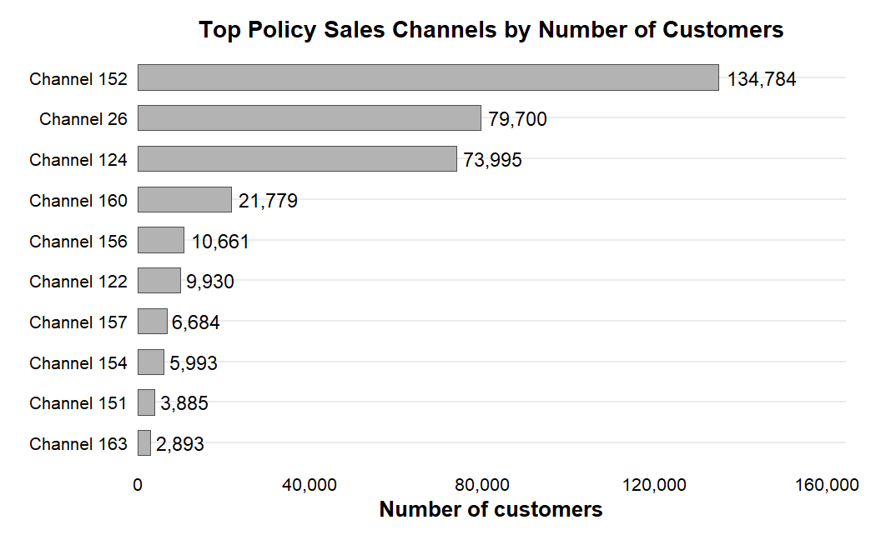Figure 3.2. Top policy sales channels by number of customers
Source: Calculation from the original dataset.
This figure justifies the focus on channel 26 and channel 124. Showing the largest channel groups helps demonstrate that the selected comparison has sufficient sample size for causal estimation.
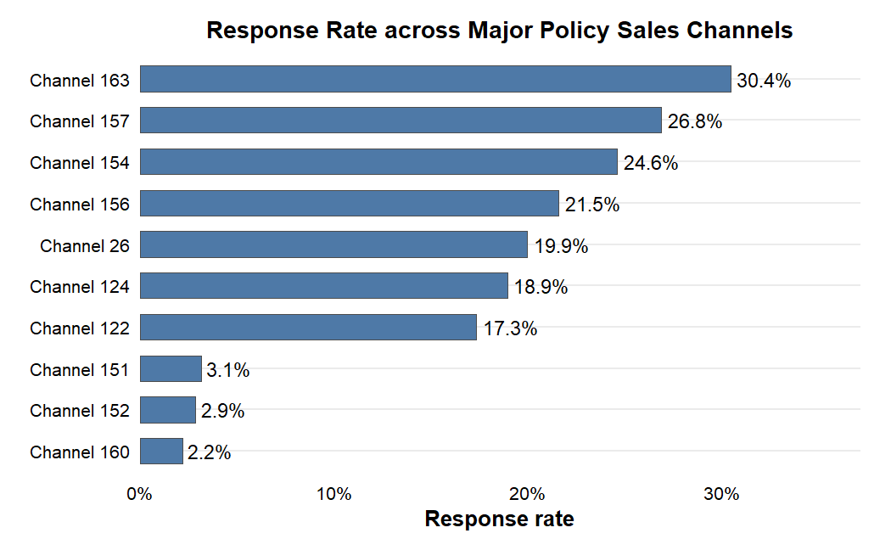
Figure 3.3. Response rate across major policy sales channels
Source: Calculation from the original dataset.
Differences in response rates across channels suggest that sales channel assignment is related to customer response, but they do not establish a causal effect because customers are not randomly assigned to channels.

3.1.3. Final analysis sample
After restricting the dataset to customers assigned to channel 26 and channel 124, the final analysis sample contains 153,695 observations. Among them, 79,700 customers are assigned to channel 26 and 73,995 customers are assigned to channel 124.
Table 3.2. Analysis sample construction
Step | Description | Observations
Original dataset | All customers | 381,109
Channel filtering | Keep only channel 26 and channel 124 | 153,695
Treatment group | Channel 26 | 79,700
Control group | Channel 124 | 73,995
Source: Calculation from the dataset.
The final sample remains large enough for matching, weighting, doubly robust estimation, and causal forest analysis. More importantly, it allows the research question to be expressed as a clear counterfactual comparison between two channel assignments.
It is also important to separate the analysis sample from the full dataset. The full dataset is useful for understanding the overall cross-selling context, but the causal estimand in this thesis is defined only for the restricted sample containing channel 26 and channel 124. Therefore, all treatment effect estimates should be interpreted for this analysis sample rather than for all possible policy sales channels in the original dataset. This prevents overgeneralization and keeps the interpretation aligned with the empirical design.

3.2. Variable Definition

3.2.1. Outcome and treatment variables
The outcome variable is customer response to the vehicle insurance offer. It is coded as 1 if the customer responds positively and 0 otherwise. The outcome variable is binary:
$$Y_{i}∈\{0,1\}$$
where $Y_{i}=1$ represents a positive customer response and $Y_{i}=0$represents no response.
The treatment variable is constructed from Policy_Sales_Channel. Customers assigned to channel 26 are coded as treated customers, while customers assigned to channel 124 are coded as control customers. The treatment variable is defined as:
$$T_{i}=\left\{\begin{matrix}1, & \text{if customer }i\text{ is assigned to channel 26} \\ 0, & \text{if customer }i\text{ is assigned to channel 124}\end{matrix}\right.$$
Thus, the main comparison is between channel 26 and channel 124.

3.2.2. Pre-treatment covariates
The observed covariates used for adjustment are gender, age, region_code, previously_insured, vehicle_age, vehicle_damage, log_annual_premium, and vintage. These variables are treated as observed pre-treatment covariates. They are customer-level characteristics that plausibly exist before the response outcome is observed and may affect both channel assignment and customer response.
For example, age, region, previous insurance status, vehicle characteristics, and premium level may influence both how customers are assigned to sales channels and how likely they are to respond. Because the dataset does not provide a detailed timestamp for each step of channel allocation, the pre-treatment interpretation is based on the business meaning of the variables and the dataset description.
The original variable annual_premium is highly right-skewed. Therefore, it is transformed into log_annual_premium. The log transformation is defined as:
$$log_annual_premium_{i}=log\left(1+annual_premium_{i}\right)$$
This transformation reduces the influence of extreme values and improves the stability of regression-based models.
The interpretation of annual premium also requires caution. Premium may reflect vehicle characteristics, customer risk profile, or internal pricing rules. In a predictive model, the raw premium value could be used directly if it improves accuracy. In a causal adjustment model, however, extreme values may create instability in regression and propensity score estimation. The log transformation therefore serves a practical modeling purpose: it preserves the ranking information in premium while reducing the influence of very large observations.
The pre-treatment status of the adjustment variables is important for the validity of the causal design. Variables that occur after treatment assignment should not be included in the adjustment set because they may mediate the treatment effect or introduce post-treatment bias. In this study, the selected variables are interpreted as customer characteristics available before the response outcome is observed. They describe who the customer is, what insurance and vehicle characteristics the customer has, and how long the customer has been associated with the company. This is why they are treated as plausible pre-treatment covariates.
The variable driving_license is not included in the core adjustment set because it is nearly constant in the selected analysis sample and provides little discriminatory information. Including variables with almost no variation may add complexity without improving adjustment quality. The final adjustment set therefore focuses on covariates that are both theoretically meaningful and empirically informative.
Table 3.3. Variable description and role
Variable | Description | Role
response | Customer response to the vehicle insurance offer | Outcome
policy_sales_channel | Coded policy sales channel | Treatment source
treat_num | 1 for channel 26, 0 for channel 124 | Treatment
gender | Customer gender | Pre-treatment covariate
age | Customer age | Pre-treatment covariate
region_code | Customer region code | Pre-treatment covariate
previously_insured | Whether the customer was previously insured | Pre-treatment covariate
vehicle_age | Age category of the vehicle | Pre-treatment covariate
vehicle_damage | Whether the vehicle had prior damage | Pre-treatment covariate
annual_premium | Original annual premium | Original financial variable
log_annual_premium | Log-transformed annual premium | Pre-treatment covariate
vintage | Number of days associated with the company | Pre-treatment covariate
Source: Synthesis from the dataset.

3.3. Descriptive Statistics and Baseline Differences

3.3.1. Descriptive statistics
The final analysis sample has an overall response rate of approximately 19.45%, which is higher than the response rate in the full dataset. This is because the analysis sample focuses only on channel 26 and channel 124, which are relatively active channels.
The average age in the analysis sample is approximately 48.9 years. The annual premium variable is strongly right-skewed, which supports the use of the log-transformed premium variable. The variable vintage is relatively widely distributed, showing variation in customer relationship length.
Table 3.4. Descriptive statistics of the analysis sample
Variable | Value
Number of observations | 153,695
Overall response rate | 19.45%
Mean age | 48.9
Mean vintage | 154.2
Male proportion | 63.14%
Previously insured proportion | 29.46%
Vehicle damage = Yes | 67.64%
Source: Calculation from the analysis sample.
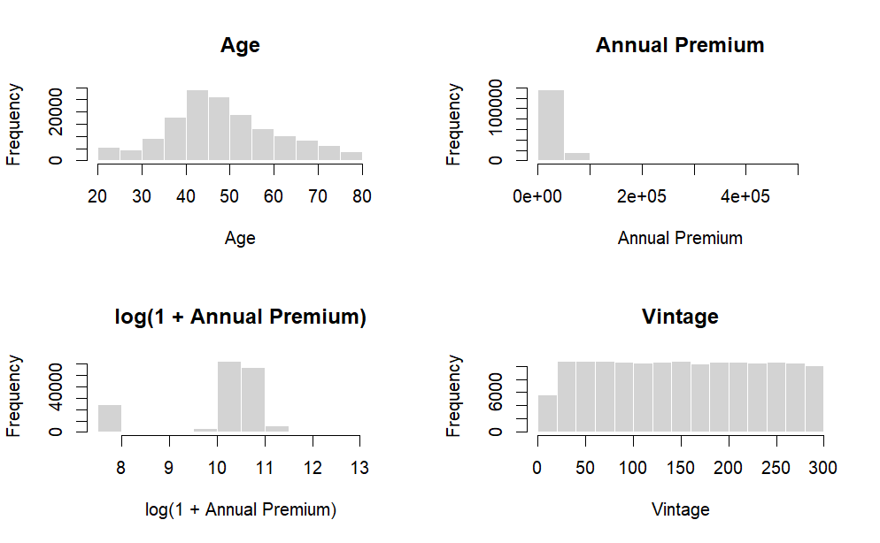Figure 3.4. Distribution of key numerical variables in the analysis sample
Source: Calculation from the analysis sample.
This figure shows the distributions of age, annual premium, log annual premium, and vintage. It is used to summarize important numerical covariates and to justify the log transformation for annual premium.
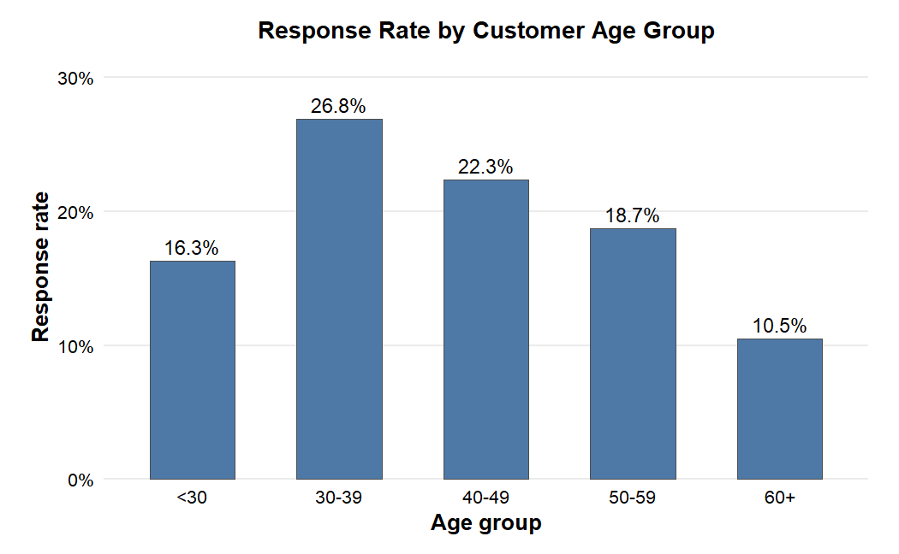Figure 3.5. Response rate by customer age group
Source: Calculation from the analysis sample.
This figure shows that customer response varies across age groups. This supports the inclusion of age as a pre-treatment covariate in the adjustment set.
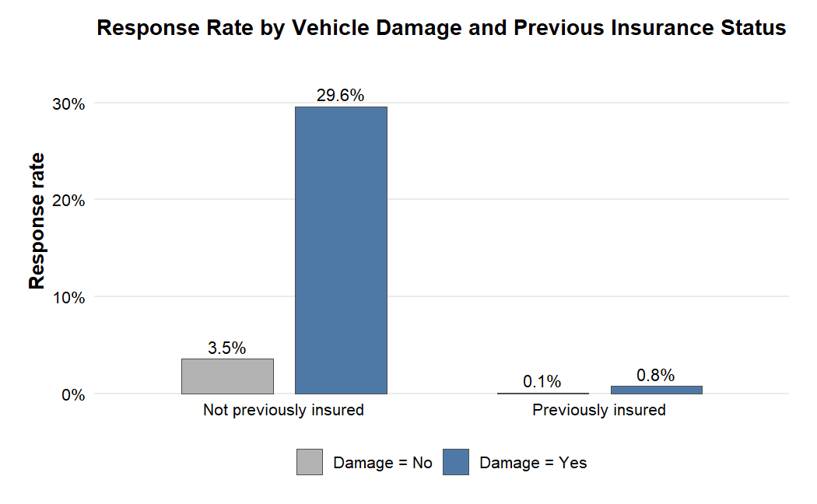Figure 3.6. Response rate by vehicle damage and previous insurance status
Source: Calculation from the analysis sample.
This figure illustrates how response patterns differ by vehicle damage and previous insurance status. These differences provide descriptive support for including these variables in the treatment assignment and outcome models.

3.3.2. Response rate by treatment group
In the analysis sample, channel 26 has a response rate of approximately 19.94%, while channel 124 has a response rate of approximately 18.91%. The raw difference is therefore about 1.02 percentage points in favor of channel 26.
The raw response rate difference is:
$$Δ_{raw}=μ_{Y,1}-μ_{Y,0}$$
where $Y,1$ is the average response rate in the treatment group and $Y,0$is the average response rate in the control group. However, this raw difference is descriptive only. It should not be interpreted as a causal effect because customers in the two channel groups may differ in their characteristics.
The raw difference can be useful as a starting point because it shows what a naive comparison would suggest. Nevertheless, it should be separated clearly from the causal estimand. If the treatment and control groups differ systematically in age, region, vehicle characteristics or insurance history, the raw difference combines both channel-related differences and customer composition differences. This is why the empirical analysis proceeds from descriptive comparison to covariate balance assessment and then to adjusted causal estimators.
Table 3.5. Response rate by treatment group
Group | Sample size | Number of responses | Response rate
Channel 124 | 73,995 | 13,996 | 18.91%
Channel 26 | 79,700 | 15,891 | 19.94%
Source: Calculation from the analysis sample.

3.3.3. Baseline imbalance
Before estimating treatment effects, it is necessary to examine whether the treatment and control groups are comparable. Since policy sales channel assignment is not randomized, customers in channel 26 and channel 124 may differ before adjustment. Baseline imbalance is assessed using standardized mean differences.
The standardized mean difference is defined as:
$$SMD=\frac{μ_{X,1}-μ_{X,0}}{s_{pooled}}$$
where X,1 is the mean of covariate (X) in the treatment group, X,0 is the meanof covariate (X) in the control group, and $s_{pooled}$ is the pooled standard deviation. In practice, an absolute SMD below 0.1 is often interpreted as a low level of imbalance, while larger values indicate stronger baseline differences.
In this study, the largest imbalance appears in age, region code, and vehicle age. This confirms that adjustment is necessary before interpreting the difference in response rates as a causal effect.
Table 3.6. Baseline characteristics by treatment group
Variable | Channel 124 | Channel 26
Sample size | 73,995 | 79,700
Response rate | 18.91% | 19.94%
Mean age | 46.9 | 50.7
Mean annual premium | 31,710 | 33,654
Mean vintage | 154.0 | 154.0
Female proportion | 35.29% | 38.31%
Previously insured proportion | 28.50% | 30.34%
Vehicle damage = Yes | 67.90% | 67.39%
Vehicle age < 1 year | 4.91% | 6.17%
Vehicle age 1-2 years | 89.36% | 85.00%
Vehicle age > 2 years | 5.73% | 8.83%
Source: Calculation from the analysis sample.

3.4. Causal Research Design and DAG Check

3.4.1. The Role of Directed Acyclic Graphs
A directed acyclic graph is used to make the identification logic explicit. Following Pearl’s causal inference framework, the DAG specifies the assumed relationships among observed covariates, policy sales channel assignment, and customer response. In this thesis, policy sales channel assignment is the treatment, customer response is the outcome, and observed customer characteristics are treated as pre-treatment covariates.
The purpose of using a DAG is not only to visualize the research design, but also to clarify which variables should be adjusted for. A DAG helps avoid common adjustment mistakes, such as controlling for post-treatment variables or colliders, which may open non-causal paths and introduce spurious associations.
To make the identification strategy transparent, the causal design is divided into two layers. The first layer is the Observable DAG, which includes only variables observed in the dataset and is used for formal adjustment-set checking. The second layer is the Conceptual DAG, which introduces a latent unobserved factor U to acknowledge the possible limitation of hidden confounding. This two-layer presentation allows the thesis to formally check the adjustment strategy while still recognizing the limitations of observational data.

3.4.2. Observable DAG and Back-door Criterion Check
Under the selection-on-observables framework, the Observable DAG includes the treatment, the outcome, and the observed pre-treatment covariates available in the dataset. The treatment is assignment to policy sales channel 26 rather than channel 124, and the outcome is customer response.
The adjustment set is defined as:
$$X_{i}=\{G_{i},A_{i},R_{i},PI_{i},VA_{i},VD_{i},LP_{i},V_{i}\}$$
where $G_{i}$is gender, $A_{i}$ is age, $R_{i}$ is region code, $PI_{i}$ is previously insured status, $VA_{i}$ is vehicle age, $VD_{i}$ is vehicle damage, $LP_{i}$ is log annual premium, and $V_{i}$ is vintage.
This adjustment set is used consistently in benchmark models, propensity score estimation, PSM, IPW, AIPW, and causal forest. The purpose is to adjust for observed differences between customers assigned to channel 26 and channel 124.
The Observable DAG is formally checked using dagitty. The purpose of this check is to evaluate whether the selected pre-treatment covariates block all observed back-door paths between policy sales channel assignment and customer response. Specifically, the back-door criterion is applied to the observed-variable structure, not to the conceptual graph that includes latent confounding.
The dagitty check indicates that the proposed adjustment set blocks all observed back-door paths under the Observable DAG. This result supports the adjustment logic under the selection-on-observables framework. It should not be interpreted as proving that all confounders are observed or that hidden confounding is absent.
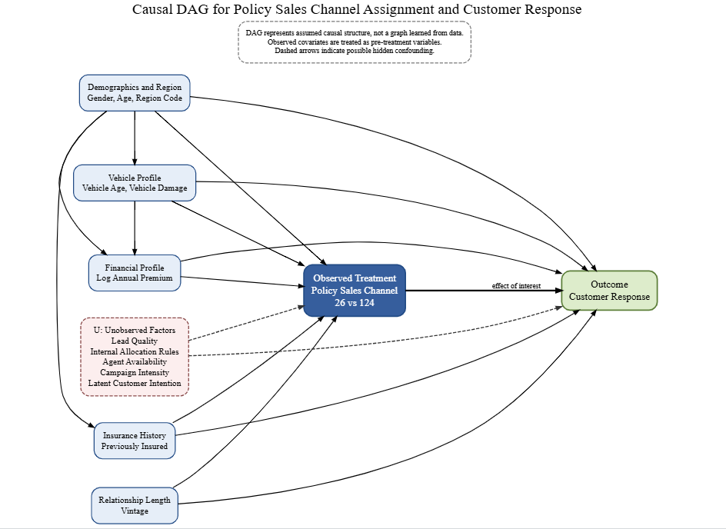Figure 3.7. Observable and conceptual DAG for policy sales channel assignment and customer response
Source: Author’s illustration.
Table 3.7. Observable DAG validation and adjustment check
Check | Purpose | Result / Interpretation
DAG specification | Define the causal graph used for identification | Observable DAG containing only measured variables
Exposure | Define treatment variable | Policy sales channel 26 vs 124
Outcome | Define outcome variable | Customer response
Back-door criterion | Check whether observed covariates block non-causal paths | Blocks all observed back-door paths under the Observable DAG
Adjustment set | Identify covariates used for adjustment | gender, age, region_code, previously_insured, vehicle_age, vehicle_damage, log_annual_premium, vintage
Interpretation | Clarify meaning of DAG check | Supports the adjustment logic under the Observable DAG; causal interpretation still relies on selection-on-observables
Source: Author’s calculation using dagitty.

3.4.3. Conceptual DAG and Hidden Confounding Limitation
Although the Observable DAG supports the formal adjustment strategy, this result depends on the selection-on-observables assumption. Because the dataset is observational and the exact business logic behind policy sales channel assignment is not observed, hidden confounding may still exist.
To transparently acknowledge this limitation, the study introduces a Conceptual DAG that includes a latent unobserved factor U. This factor represents possible hidden variables such as lead quality, internal channel allocation rules, agent availability, campaign intensity, or latent customer purchase intention.
The hidden confounding structure is expressed as:
$$U→T_{i}, U→Y_{i}$$
This structure means that an unobserved factor may affect both policy sales channel assignment and customer response. If such a factor is important, an unblocked back-door path remains:
$$T_{i}←U→Y_{i}$$
In this case, the back-door path through U remains unblocked, and the causal effect cannot be fully identified using observed covariates alone. Therefore, the formal dagitty check should be interpreted as a check of the observed adjustment strategy under the Observable DAG, not as proof that hidden confounding is absent.
Table 3.8. Conceptual DAG and hidden confounding interpretation
Check | Result
Latent confounder included | Yes, in the Conceptual DAG
Meaning of U | Lead quality, internal allocation rules, agent availability, campaign intensity, latent customer intention
Is the observed adjustment set strictly sufficient if U exists? | No
Interpretation | If U affects both treatment and outcome, the effect is not fully identified using observed covariates only
Source: Illustration based on the specified DAG.
In summary, the causal research design combines observed covariate adjustment, formal DAG-based checking, and explicit recognition of hidden confounding limitations. The Observable DAG is used to check that the selected adjustment set blocks all observed back-door paths. The Conceptual DAG then clarifies that this check is conditional on the assumption that important confounders are observed or adequately proxied by observed covariates. This approach strengthens the transparency of the empirical design while avoiding an overstatement of causal certainty.

CHAPTER 4. METHODOLOGY

4.1. Empirical Strategy and Estimands

4.1.1. Central counterfactual question
The empirical strategy is designed around the central counterfactual question of the thesis: for a customer in the analysis sample, how would the probability of response change if the customer were assigned to policy sales channel 26 instead of policy sales channel 124?
This question is counterfactual because the same customer cannot be observed under both channel assignments at the same time. The observed data contain only one realized outcome for each customer. A customer assigned to channel 26 has an observed response under channel 26, while the response that would have occurred under channel 124 is unobserved. Similarly, a customer assigned to channel 124 has an observed response under channel 124, while the response under channel 26 is unobserved.
The empirical strategy therefore compares treated and control customers after adjusting for observed pre-treatment covariates. The adjustment set is used consistently across benchmark models, propensity score estimation, PSM, IPW, AIPW, and causal forest. This consistency is important because it ensures that differences across estimators reflect differences in estimation approach rather than differences in covariate definition.
The empirical workflow follows a layered structure. First, descriptive statistics and standardized mean differences are used to understand the initial differences between the two channel groups. Second, benchmark models are estimated to compare the raw association with covariate-adjusted associations. Third, the propensity score model is used to evaluate overlap and construct matching and weighting estimators. Fourth, PSM, IPW and AIPW are estimated and compared. Fifth, robustness and diagnostic checks are conducted to evaluate common support, negative-control behavior and permutation-based sanity. Finally, causal forest is used to examine heterogeneity and targeting value.

4.1.2. Estimand hierarchy
The thesis distinguishes among ATE, ATT and CATE because they answer related but different questions.
The main estimand is the Average Treatment Effect:
$$ATE=E\left[Y_{i}\left(1\right)-Y_{i}\left(0\right)\right]$$
ATE represents the average change in response probability if customers in the analysis sample were assigned to channel 26 rather than channel 124. AIPW is selected as the main estimator for this estimand.
The ATT is defined as:
$$ATT=E\left[Y_{i}\left(1\right)-Y_{i}\left(0\right)∣T_{i}=1\right]$$
ATT focuses on customers actually assigned to channel 26. In this thesis, PSM is used mainly as an ATT-based supporting comparison.
The CATE is defined as:
$$CATE\left(X_{i}\right)=E\left[Y_{i}\left(1\right)-Y_{i}\left(0\right)∣X_{i}\right]$$
CATE is used to examine treatment effect heterogeneity and targeting value. In particular, it helps identify which customers in channel 124 may have larger predicted incremental response if assigned to channel 26.
Table 4.1. Estimands used in the thesis
Estimand | Formula | Main role in this thesis
ATE | E[Y(1)-Y(0)] | Main estimand for average causal effect
ATT | E[Y(1)-Y(0) | T=1]
CATE | E[Y(1)-Y(0) | X]
Source: Author’s synthesis.

4.2. Identification Assumptions

4.2.1. Consistency assumption
The consistency assumption states that the observed outcome corresponds to the potential outcome under the treatment actually received. In this study, if a customer is assigned to channel 26, the observed response corresponds to the potential outcome under channel 26. If a customer is assigned to channel 124, the observed response corresponds to the potential outcome under channel 124.
Consistency is written as:
$$Y_{i}=T_{i}Y_{i}\left(1\right)+\left(1-T_{i}\right)Y_{i}\left(0\right)$$
This assumption requires that the treatment categories are sufficiently well-defined. In the present dataset, channel 26 and channel 124 are treated as stable coded channel categories. Because the public dataset does not provide further descriptions of each channel, this is an important limitation that should be considered when interpreting the results.

4.2.2. Conditional exchangeability assumption
Conditional exchangeability assumes that after adjusting for observed covariates, treatment assignment is independent of potential outcomes. In other words, within groups of customers with the same observed covariates, assignment to channel 26 rather than channel 124 is assumed not to be related to the potential response outcomes.
Conditional exchangeability is written as:
$$\left(Y_{i}\left(1\right),Y_{i}\left(0\right)\right)⊥T_{i}∣X_{i}$$
This is the key identification assumption of the thesis. It cannot be directly proven with observational data. The assumption is supported by the selection of pre-treatment covariates, the DAG-based adjustment check, and empirical diagnostics such as balance assessment and negative-control analysis. However, hidden confounding cannot be fully ruled out.

4.2.3. Positivity assumption
The positivity assumption requires that customers with similar observed characteristics have a positive probability of being assigned to either channel 26 or channel 124. If some customer profiles appear only in one channel, then there is no empirical basis for estimating the counterfactual response under the other channel.
The positivity assumption is written as:
$$0<P\left(T_{i}=1∣X_{i}\right)<1$$
Equivalently, using the propensity score:
$$0<e\left(X_{i}\right)<1$$
This assumption is examined through propensity score overlap and common support diagnostics. If the overlap is weak, matching and weighting estimates may become unstable. Therefore, common support trimming is used as an additional robustness check.

4.2.4. SUTVA and observational data limitation
The Stable Unit Treatment Value Assumption requires that one customer’s response is not affected by another customer’s treatment assignment. It also assumes that there are no multiple hidden versions of the treatment. In this thesis, SUTVA means that customer response is assumed to depend on the customer’s own channel assignment rather than the assignments of other customers.
Because the dataset is observational, the assumptions above should be interpreted carefully. The thesis does not claim that channel assignment is randomized. Instead, it estimates treatment effects under the DAG-based identification assumptions and the selection-on-observables framework.
Given the retail nature of individual vehicle insurance, interactions or spillover effects between non-household customers are highly unlikely. Thus, assigning one customer to a specific sales channel is reasonably assumed not to interfere with another customer's response decision, satisfying the core premise of SUTVA.

4.3. Benchmark and Propensity Score Model

4.3.1. Raw difference in means
The first benchmark is the raw response rate difference between the treatment and control groups. This comparison is simple and transparent, but it does not adjust for customer characteristics.
The raw difference is defined as:
$$Δ_{raw}=μ_{Y,1}-μ_{Y,0}$$
The raw difference is used only as a descriptive benchmark. It is not interpreted as a causal effect because treatment assignment is not random and the two groups differ in observed covariates.

4.3.2. Linear Probability Model
The Linear Probability Model is used as an adjusted benchmark. It estimates the association between treatment and response after controlling for observed covariates.
The model is specified as:
$$Y_{i}=α+τT_{i}+X_{i}'β+ε_{i}$$
where Y_i is the binary response outcome, T_i is the treatment indicator, and X_i is the vector of observed covariates. The coefficient tau represents the adjusted difference in response probability associated with assignment to channel 26. The LPM is easy to interpret, but it is not the main causal estimator.

4.3.3. Logistic regression benchmark
Because the outcome is binary, logistic regression is also used as a benchmark model. The logistic model is specified as:
$$P\left(Y_{i}=1∣T_{i},X_{i}\right)=\frac{exp\left(α+τT_{i}+X_{i}'β\right)}{1+exp\left(α+τT_{i}+X_{i}'β\right)}$$
The odds ratio for treatment is:
$$OR=exp\left(τ\right)$$
An odds ratio greater than 1 indicates that channel 26 is associated with higher odds of response relative to channel 124, conditional on observed covariates. To express the logistic result in probability terms, predicted probabilities can be computed under two counterfactual treatment states.
The g-computation style difference is:
$$τ_{gcomp}=\frac{1}{n}\sum_{i=1}^{n}{\left[\hat{μ}\left(1,X_{i}\right)-\hat{μ}\left(0,X_{i}\right)\right]}$$

4.3.4. Propensity score model
The propensity score is the probability of being assigned to channel 26 conditional on observed covariates.
$$e\left(X_{i}\right)=P\left(T_{i}=1∣X_{i}\right)$$
In this thesis, the propensity score is estimated using logistic regression:
$$logit\left(e\left(X_{i}\right)\right)=α+X_{i}'γ$$
The estimated propensity score is used for overlap diagnostics, PSM, IPW, AIPW, and common support trimming.

4.4. Treatment Effect Estimators

4.4.1. Propensity Score Matching
Propensity Score Matching compares treated customers with control customers who have similar estimated propensity scores. The idea is to construct a comparison group that resembles the treated group in terms of observed covariates.
For each treated customer, the nearest-neighbor matching rule is:
$$j\left(i\right)=arg\min_{j:T_{j}=0}\left|\hat{e}\left(X_{i}\right)-\hat{e}\left(X_{j}\right)\right|$$
The PSM estimator for ATT is:
τPSM=1NTi:Ti=1​Yi-Yji
where N_T is the number of treated customers. PSM is intuitive and useful for checking robustness, but it may discard observations and mainly targets the treated population.

4.4.2. Inverse Probability Weighting
Inverse Probability Weighting uses propensity scores to create a weighted pseudo-population in which treatment assignment is less dependent on observed covariates. This method retains all observations but can be sensitive to extreme propensity scores.
The stabilized inverse probability weight is defined as:
$$w_{i}=\left\{\begin{matrix}\frac{p}{\hat{e}\left(X_{i}\right)}, & \text{if }T_{i}=1 \\ \frac{1-p}{1-\hat{e}\left(X_{i}\right)}, & \text{if }T_{i}=0\end{matrix}\right.$$
The IPW estimator is the weighted treated mean outcome minus the weighted control mean outcome.
$${\hat{τ}}_{IPW}=\frac{\sum_{i=1}^{n}{w_{i}}T_{i}Y_{i}}{\sum_{i=1}^{n}{w_{i}}T_{i}}-\frac{\sum_{i=1}^{n}{w_{i}}\left(1-T_{i}\right)Y_{i}}{\sum_{i=1}^{n}{w_{i}}\left(1-T_{i}\right)}$$
IPW is used as an ATE-oriented estimator and provides a useful comparison with AIPW.

4.4.3. Augmented Inverse Probability Weighting
AIPW is the main estimator in this thesis because it combines a propensity score model and an outcome model. This doubly robust structure is useful in observational studies where model misspecification is a concern.
Let the outcome model be:
$$μ_{t}\left(X_{i}\right)=E\left[Y_{i}∣T_{i}=t,X_{i}\right]$$
The AIPW score for each observation is:
$$ψ_{i}={\hat{μ}}_{1}\left(X_{i}\right)-{\hat{μ}}_{0}\left(X_{i}\right)+\frac{T_{i}\left(Y_{i}-{\hat{μ}}_{1}\left(X_{i}\right)\right)}{\hat{e}\left(X_{i}\right)}-\frac{\left(1-T_{i}\right)\left(Y_{i}-{\hat{μ}}_{0}\left(X_{i}\right)\right)}{1-\hat{e}\left(X_{i}\right)}$$
The AIPW estimator is:
$${\hat{τ}}_{AIPW}=\frac{1}{n}\sum_{i=1}^{n}{ψ_{i}}$$
The standard error is calculated from the empirical variation of the AIPW scores:
$$SE\left({\hat{τ}}_{AIPW}\right)=\frac{sd\left(ψ_{i}\right)}{\sqrt{n}}$$
The 95% confidence interval is:
$${\hat{τ}}_{AIPW}±1.96×SE\left({\hat{τ}}_{AIPW}\right)$$
AIPW is used as the central estimate because it directly targets the ATE and combines information from both the treatment model and the outcome model.

4.5. Diagnostics and Heterogeneity Methods

4.5.1. Common support trimming
Common support trimming is used to assess whether the main AIPW estimate is sensitive to observations with weak overlap. Observations with very low or very high propensity scores may have poorly supported counterfactual outcomes. The 1%-99% trimmed support rule is:
$$q_{0.01}≤\hat{e}\left(X_{i}\right)≤q_{0.99}$$
The AIPW estimator is recalculated on the trimmed sample. If the trimmed estimate remains close to the full-sample estimate, this suggests that the main result is not driven by weak-overlap observations.

4.5.2. Negative-control outcome diagnostic
A negative-control outcome diagnostic is used to check whether the empirical pipeline produces a spurious effect on a variable that should not be affected by treatment. In this thesis, gender is used as a negative-control outcome because policy sales channel assignment cannot causally change a customer’s gender.
Let Y_i^{NC} denote the negative-control outcome. The expected diagnostic result is:
$$τ_{NC}≈0$$
If the estimated effect of channel assignment on the negative-control outcome is close to zero and statistically insignificant, this supports the sanity of the empirical pipeline. However, this diagnostic does not prove that there is no hidden confounding.

4.5.3. Permutation-based pipeline sanity check
The permutation-based check is used as a pipeline sanity check rather than a definitive causal proof. In this procedure, the treatment assignment is randomly permuted while the outcome and covariates are kept unchanged.
For permutation iteration b, the permuted treatment is:
$$T_{i}^{perm,b}=π_{b}\left(T_{i}\right)$$
The estimator is recalculated under the permuted treatment assignment to obtain ${\hat{τ}}_{perm}^{\left(b\right)}, b=1,…,B$. In this empirical analysis, the permutation-based check was implemented with 1,000 permutations (B = 1,000) to construct a robust placebo distribution.
This check evaluates whether the estimation pipeline produces near-zero effects when treatment labels are randomized. It does not rule out hidden confounding and should not be interpreted as proof of causal validity.

4.5.4. Causal forest, RATE and Qini analysis
Causal forest is used to estimate heterogeneous treatment effects. The main quantity of interest is the CATE:
$$τ\left(X_{i}\right)=E\left[Y_{i}\left(1\right)-Y_{i}\left(0\right)∣X_{i}\right]$$
The causal forest produces individual-level treatment effect estimates:
$$\hat{τ}\left(X_{i}\right)$$
The average causal forest estimate is:
$${\hat{τ}}_{CF}=\frac{1}{n}\sum_{i=1}^{n}{\hat{τ}}\left(X_{i}\right)$$
RATE and Qini diagnostics are used to assess whether the CATE ranking has targeting value. If customers with higher predicted CATE also generate larger incremental gains, the ranking is useful for targeting. The targeting analysis focuses on customers originally assigned to channel 124.

CHAPTER 5. EMPIRICAL RESULTS AND DISCUSSION

5.1. Descriptive Results and Baseline Imbalance

5.1.1. Descriptive statistics by treatment group
The first empirical step is to compare the treatment and control groups before adjustment. The analysis sample includes 79,700 customers in channel 26 and 73,995 customers in channel 124. The response rate is 19.94% for channel 26 and 18.91% for channel 124. The raw difference is positive but small, approximately 1.02 percentage points.
The descriptive statistics also show that the two groups are not identical. Customers in channel 26 are older on average, have slightly higher annual premium, and differ in vehicle age distribution. These baseline differences are important because they indicate that raw response rates are not sufficient for causal interpretation.
These differences motivate the use of adjusted estimators. The raw response-rate gap is reported as a descriptive benchmark, while the causal interpretation is based on models that adjust for observed pre-treatment covariates.
Table 5.1. Descriptive statistics by treatment group
Variable | Channel 124 | Channel 26 | Interpretation
Sample size | 73,995 | 79,700 | Groups are large and balanced
Response rate | 18.91% | 19.94% | Raw difference favors channel 26
Mean age | 46.9 | 50.7 | Treated customers are older
Mean annual premium | 31,710 | 33,654 | Treated customers pay slightly more
Mean vintage | 154.0 | 154.0 | Very similar relationship length
Previously insured | 28.50% | 30.34% | Slight difference
Vehicle damage = Yes | 67.90% | 67.39% | Very similar
Source: Calculation from the analysis sample.

5.1.2. Standardized Mean Difference analysis
Standardized Mean Difference analysis confirms that some covariates differ before adjustment. The largest imbalance is found in age, region code, and vehicle age. These variables are also plausible confounders because they may affect both channel assignment and response.
Table 5.2. Baseline SMD before adjustment
Variable | Approximate SMD | Interpretation
Age | 0.301 | Meaningful imbalance
Region code | 0.239 | Meaningful imbalance
Vehicle age | 0.135 | Moderate imbalance
Gender | 0.063 | Low imbalance
Log annual premium | 0.063 | Low imbalance
Previously insured | 0.040 | Low imbalance
Vehicle damage | 0.011 | Very low imbalance
Vintage | 0.002 | Very low imbalance
Source: Calculation from the analysis sample.
The imbalance is not extreme across all variables, but it is sufficiently large in several important covariates to require adjustment. This supports the use of propensity score methods and doubly robust estimation.
The SMD results provide a scale-free measure of imbalance. This is preferable to relying only on p-values because large datasets can produce statistically significant differences even when the magnitude is small. SMD focuses on the size of the difference relative to the variability of the covariate. For this reason, it is commonly used in propensity score diagnostics. In the context of this thesis, the SMD analysis shows that adjustment is not merely optional but necessary for a credible comparison between channel 26 and channel 124.

5.1.3. Love plot before adjustment
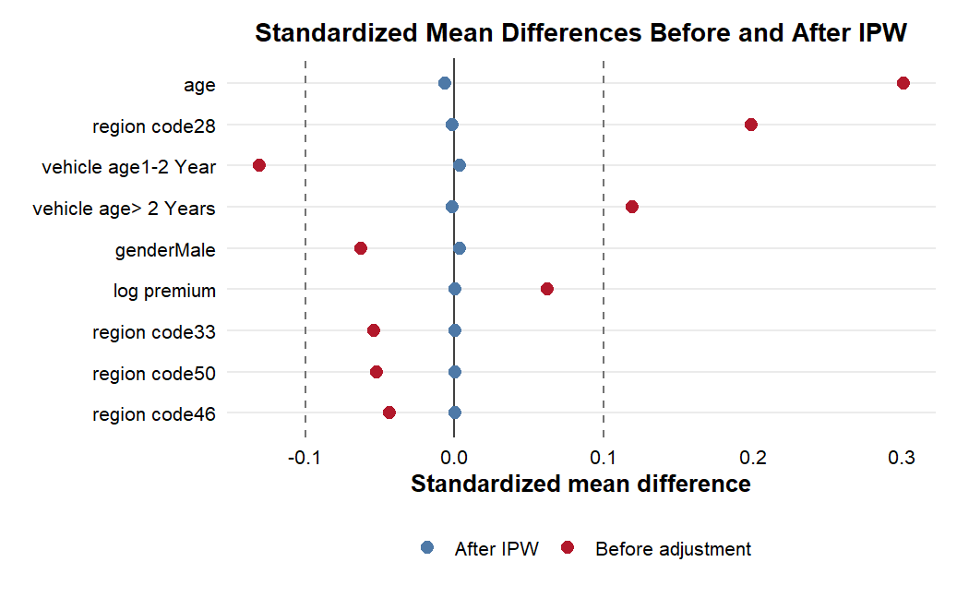Figure 5.1. Standardized mean differences before and after IPW
Source: Calculation from balance diagnostics.
This figure visually compares covariate balance before and after IPW. The plot is important because it shows whether the weighting procedure reduces observed baseline imbalance between channel 26 and channel 124.

5.2. Propensity Score and Overlap Diagnostics

5.2.1. Propensity score overlap distribution
The propensity score model estimates the probability of being assigned to channel 26 conditional on observed covariates. The resulting distributions show reasonable but not perfect overlap, which is important because treatment effect estimation requires comparable treated and control customers.
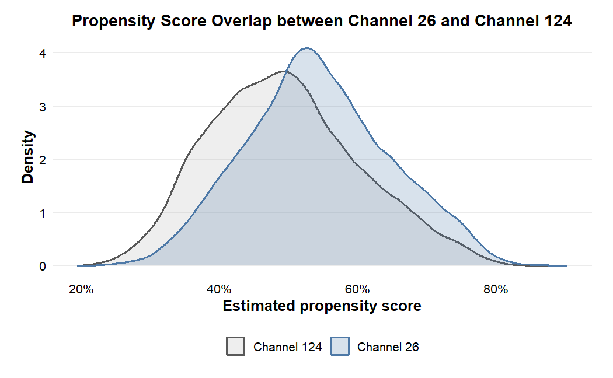Figure 5.2. Propensity score overlap between channel 26 and channel 124
Source: Calculation from the analysis sample.
The two distributions share a broad common region, although some observations remain near the tails of the propensity score distribution.
This overlap supports the use of matching and weighting methods, while the remaining tail observations motivate the common support trimming check reported below.

5.2.2. Common support and trimmed sample
The 1%-99% trimming rule keeps observations whose propensity scores fall within the central support region. In the updated common support check, 150,621 observations are kept, corresponding to 98.00% of the analysis sample, while 3,074 observations are trimmed out.
Table 5.3. Common support and trimmed sample
Sample | Observations | Share | Treated rate | Interpretation
Full sample | 153,695 | 100.00% | 51.86% | Reference sample
Kept in common support | 150,621 | 98.00% | 52.0% | Main common-support sample
Trimmed out | 3,074 | 2.00% | 45.9% | Weak-overlap observations
Source: Calculation from propensity score diagnostics.
The high proportion kept indicates that common support is acceptable. The trimmed-out group represents about 2.00% of the analysis sample, has a slightly lower response rate (18.2%), a lower treated rate (45.9%), a higher mean age (50.4), and a lower mean annual premium than the kept group. Therefore, the trimmed estimate should be interpreted as applying primarily to customers inside the common support region, but the small trimmed share suggests that the main findings are unlikely to be driven only by weak-overlap observations.

5.2.3. Covariate balance after adjustment
Matching and weighting are expected to reduce observed imbalance. The balance diagnostics show that the largest baseline differences become much smaller after adjustment. This is especially important for age, region code, and log annual premium.
Variable | Before adjustment | After matching/weighting | Interpretation
Age | High imbalance | Substantially reduced | Adjustment successful
Region code | High imbalance | Substantially reduced | Adjustment successful
Vehicle age | Moderate imbalance | Reduced | Adjustment improves balance
Log annual premium | Low imbalance | Near zero | Stable
Vintage | Near zero | Near zero | Already balanced
Source: Calculation from balance diagnostics.
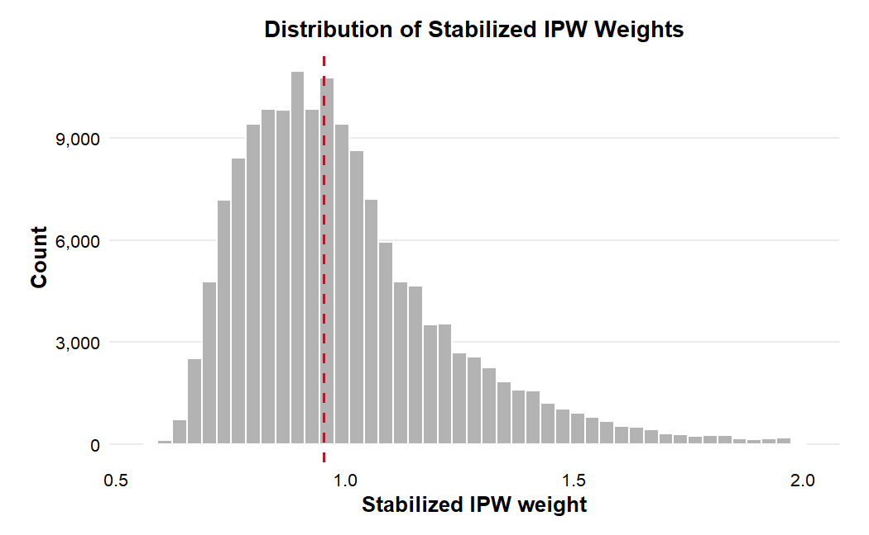Figure 5.3. Distribution of stabilized inverse probability weights
Source: Calculation from the analysis sample.
This figure is inserted to inspect whether the IPW estimates are dominated by extreme weights. A stable weight distribution supports the reliability of the weighting-based treatment effect estimates.

5.3. Main Causal Estimates

5.3.1. Benchmark model results
Benchmark models provide an initial comparison before the main causal estimators. The raw difference is approximately 1.02 percentage points. After controlling for observed covariates, the LPM and logistic benchmark suggest a larger positive association between channel 26 and customer response.
Table 5.5. Benchmark model results
Model | Quantity reported | Estimate | Interpretation
Raw difference | Response rate difference | 0.0102 | Descriptive only
LPM | Adjusted treatment coefficient | 0.0236 | Positive adjusted association
Logistic regression | Odds ratio | 1.219 | Channel 26 associated with higher odds
Logistic g-computation | Probability difference | 0.0265 | Positive adjusted probability difference
Source: Calculation from benchmark models.
These results are not treated as the main causal estimates, but they provide useful context. They show that the positive relationship between channel 26 and response remains after controlling for observed covariates.
The main estimates should be read as a sequence rather than as isolated numbers. The raw difference is the unadjusted starting point. The benchmark models show how the association changes after covariate adjustment. PSM, IPW and AIPW then provide treatment effect estimates under different adjustment strategies. The fact that the estimates are positive across methods provides stronger evidence than any single estimate alone. Nevertheless, AIPW is treated as the central result because it targets the ATE and uses both treatment and outcome models.

5.3.2. Main treatment effect estimates
The main causal estimates are reported using PSM, IPW, and AIPW. AIPW is the central estimator because it combines the propensity score model and the outcome model.
Table 5.6. Main causal estimates
Method | Estimand | Estimate | Standard error | 95% CI | Percentage points
PSM | ATT | 0.0069 | 0.0021 | [0.0029, 0.0109] | 0.69 pp
IPW | ATE | 0.0238 | 0.0021 | [0.0198, 0.0278] | 2.38 pp
AIPW | ATE | 0.0264 | 0.0019 | [0.0227, 0.0302] | 2.64 pp
Source: Calculation from PSM, IPW and AIPW estimators.
The AIPW estimate indicates that, under the observed covariate adjustment strategy and the selection-on-observables assumption, assignment to channel 26 rather than channel 124 is associated with an average increase of approximately 2.64 percentage points in response probability. This is the main estimate of the thesis. The adjusted AIPW estimate is larger than the raw response-rate difference, which suggests that the observed customer composition partly suppresses the unadjusted comparison. After adjusting for age, insurance history, vehicle profile, region, premium and vintage, the estimated incremental effect of channel 26 becomes larger than the descriptive gap.

5.3.3. Confidence interval comparison
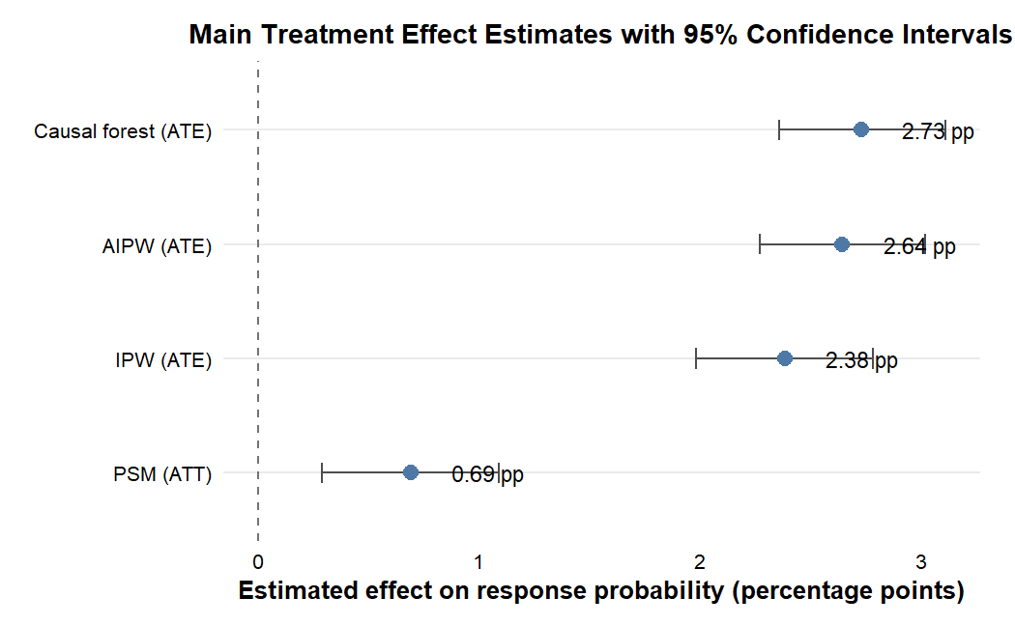Figure 5.4. Main treatment effect estimates with 95% confidence intervals
Source: Calculation from PSM, IPW and AIPW estimators.
The confidence interval comparison helps summarize the magnitude and uncertainty of the main estimates. IPW and AIPW are close in magnitude, while PSM is smaller but still positive. This difference is not necessarily a contradiction because PSM mainly targets the ATT among customers already assigned to channel 26, whereas AIPW targets the ATE for the full analysis sample. A smaller ATT may indicate that the incremental gain among customers already in channel 26 is limited, while some customers originally assigned to channel 124 may have larger counterfactual gains under channel 26. This interpretation is consistent with the later targeting analysis.

5.4. Robustness and Diagnostic Checks

5.4.1. Full sample versus trimmed sample AIPW
The trimmed AIPW analysis evaluates whether the main estimate is sensitive to weak-overlap observations. After trimming the 1%-99% propensity score support, the AIPW estimate remains close to the full-sample estimate.
Table 5.7. Full sample versus trimmed sample AIPW
Sample | Observations | ATE | Standard error | 95% CI
Full sample | 153,695 | 0.0264 | 0.0019 | [0.0227, 0.0302]
Trimmed 1%-99% support | 150,621 | 0.0269 | 0.0019 | [0.0231, 0.0307]
Source: Calculation from AIPW robustness diagnostics.
The similarity between the two estimates suggests that the main result is not driven by extreme propensity score observations.

5.4.2. Negative-control outcome results
A negative-control outcome diagnostic is conducted using gender as the pseudo-outcome. Since policy sales channel assignment cannot causally change customer gender, the estimated effect should be close to zero if the empirical pipeline does not mechanically generate spurious effects.
Table 5.8. Negative-control outcome diagnostic
Diagnostic | Pseudo-outcome | Estimator | Estimate | Standard error | 95% CI | p-value
Negative-control outcome | Gender = Male | AIPW | 0.0016 | 0.0025 | [-0.0034, 0.0066] | 0.527
Source: Calculation from negative-control diagnostic.
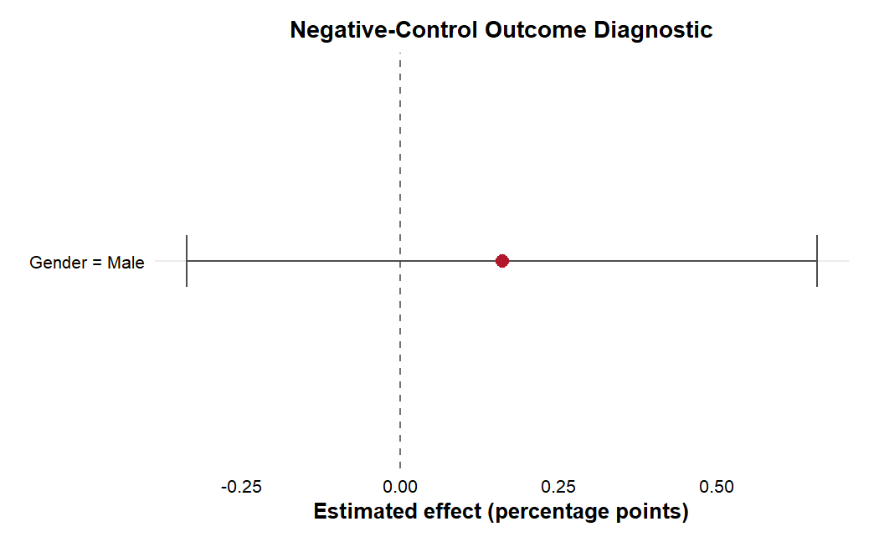Figure 5.5. Negative-control outcome diagnostic
Source: Calculation from negative-control diagnostic.
This figure shows the negative-control estimate and its confidence interval around zero. This visual diagnostic supports the interpretation that the empirical pipeline does not mechanically generate a spurious effect on a pre-treatment outcome.
The estimate is close to zero and statistically insignificant. This is an important sanity check because a large estimated effect on gender would indicate serious imbalance or misspecification in the empirical pipeline. Since this is not observed, the diagnostic reduces concern that the estimation procedure is mechanically producing artificial treatment effects. However, it remains supportive evidence rather than proof that all hidden confounding has been eliminated.

5.4.3. Permutation-based pipeline sanity check results
The permutation-based pipeline sanity check randomly permutes treatment labels while keeping the outcome and covariates unchanged. The purpose is to examine whether the estimation pipeline produces near-zero effects when treatment assignment is randomized.The final diagnostic was executed using 1,000 random permutations; the reported empirical p-value should reflect the actual number of permutations used.
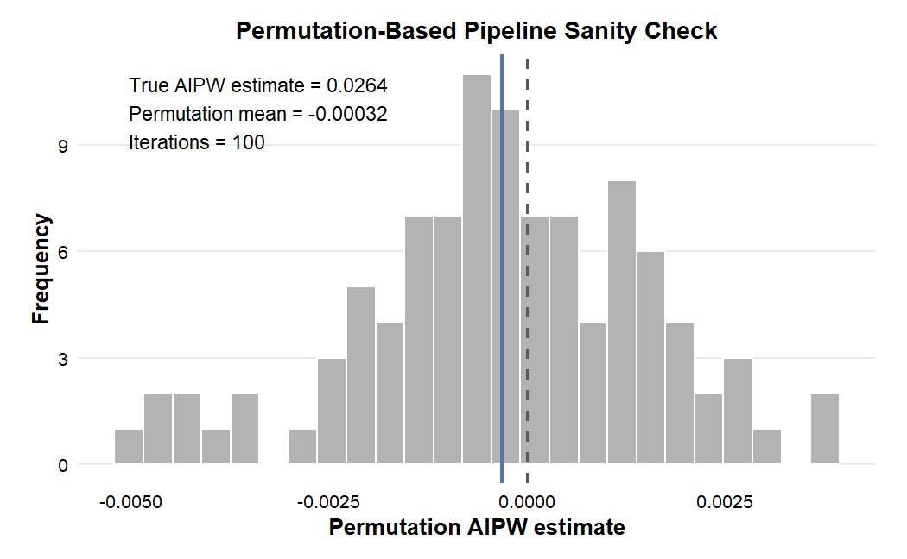Figure 5.6. Permutation-based pipeline sanity check distribution
Source: Calculation from permutation diagnostics.
The permutation distribution is expected to be centered close to zero, while the true estimate is substantially larger in magnitude. This indicates that the observed estimate is not simply produced by random label permutation. Nevertheless, the test should be interpreted as a pipeline sanity check, not as proof of causal identification.

5.5. Causal Forest and Heterogeneity Analysis

5.5.1. Average Treatment Effect by target sample
Causal forest is used to examine whether the treatment effect varies across customer characteristics. Before interpreting heterogeneity, the average treatment effect from causal forest is compared with the main AIPW result.
Table 5.9. Causal forest ATE by target sample
Target sample | Estimate | Standard error | 95% CI | Percentage points
All | 0.0273 | 0.0019 | [0.0236, 0.0311] | 2.73 pp
Treated | 0.0305 | 0.0019 | [0.0268, 0.0342] | 3.05 pp
Control | 0.0239 | 0.0020 | [0.0200, 0.0278] | 2.39 pp
Overlap | 0.0271 | 0.0019 | [0.0234, 0.0308] | 2.71 pp
Source: Calculation from causal forest.
The causal forest ATE for the full sample is close to the AIPW estimate. This consistency supports the stability of the average positive effect.

5.5.2. Calibration test
The calibration test evaluates whether the causal forest predictions contain meaningful treatment effect information. In particular, the differential forest prediction tests whether the model captures heterogeneity beyond the average effect.
Table 5.10. Causal forest calibration test
Term | Estimate | Standard error | t-value | p-value | Interpretation
Mean forest prediction | 0.9853 | 0.0685 | 14.38 | <0.001 | Average prediction calibrated
Differential forest prediction | 0.9579 | 0.0530 | 18.09 | <0.001 | Heterogeneity signal significant
Source: Calculation from causal forest calibration test.
The significant differential forest prediction suggests that the forest captures meaningful heterogeneity rather than only random noise.

5.5.3. CATE distribution
The estimated CATE distribution shows that treatment effects are not identical across customers. Many CATE values are concentrated around zero, while a smaller group of customers has substantially positive predicted effects. The mean CATE is approximately 2.79 percentage points and the 95th percentile is around 10.1 percentage points.
Table 5.11. Distribution of estimated CATE
Statistic | Value
Mean | 0.0279
Standard deviation | 0.0417
1st percentile | -0.0703
5th percentile | -0.0254
25th percentile | 0.0003
Median | 0.0189
75th percentile | 0.0537
95th percentile | 0.1010
99th percentile | 0.1520
Source: Calculation from causal forest predictions.
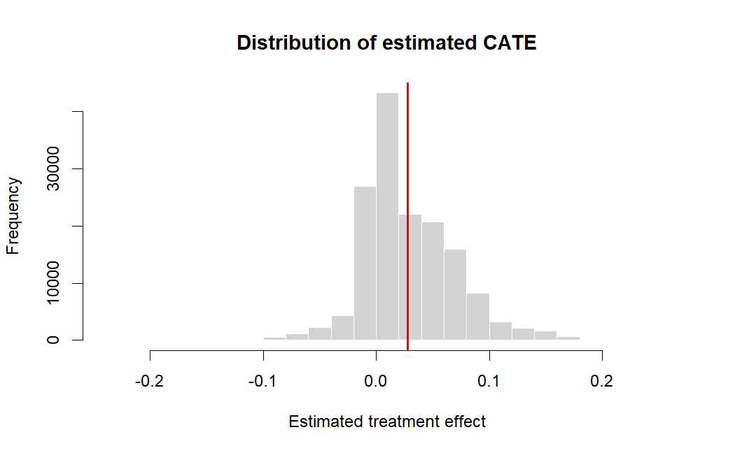Figure 5.7. Distribution of estimated CATE
Source: Calculation from causal forest.
Figure 5.7 presents the distribution of the estimated CATE. To exclude extreme outliers and improve visual clarity, the histogram is restricted to the 1st and 99th percentiles. The plot illustrates that while many customers exhibit near-zero effects, a distinct segment shows substantially positive predicted gains.

5.5.4. Variable importance analysis
Variable importance analysis indicates which covariates are most relevant for explaining treatment effect heterogeneity. The most important variables include vehicle age, vehicle damage, age, previously insured status, log annual premium, region code, and vintage.
Table 5.12. Causal forest variable importance
Rank | Variable | Interpretation
1 | Vehicle age > 2 years | Older vehicles strongly related to heterogeneity
2 | Vehicle damage = Yes | Damage history differentiates treatment response
3 | Age | Older customers respond differently
4 | Previously insured | Insurance history matters
5 | Log annual premium | Premium level contributes to heterogeneity
6 | Region code | Geographic/customer segment differences
7 | Vintage | Relationship length adds information
Source: Calculation from causal forest.
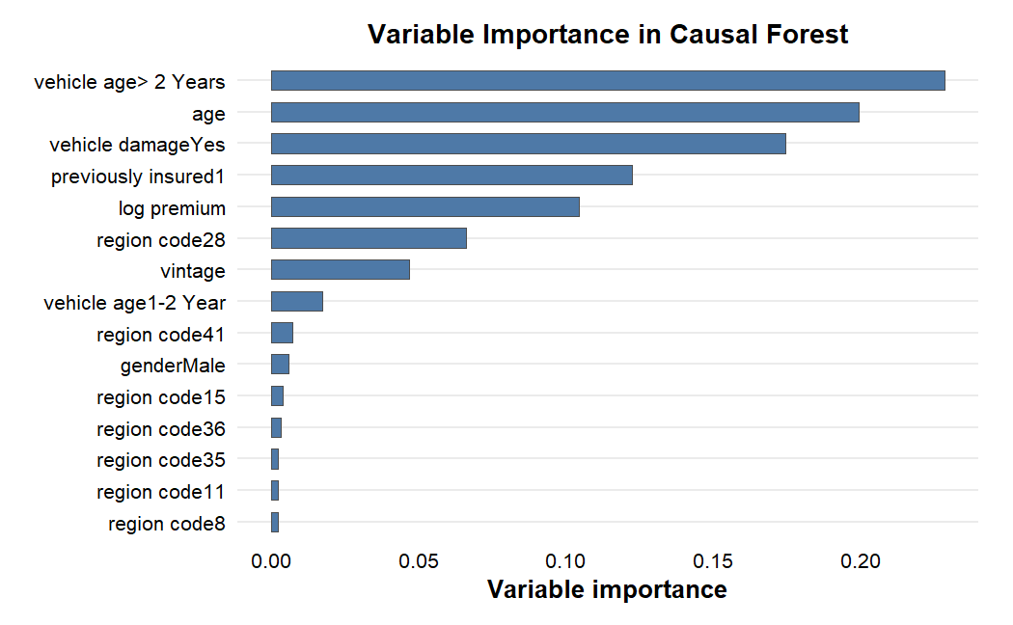Figure 5.8. Variable importance in causal forest
Source: Calculation from causal forest.

5.6. Targeting Analysis among Channel 124 Customers

5.6.1. RATE and Qini diagnostic results
RATE and Qini diagnostics evaluate whether ranking customers by estimated CATE provides targeting value. Positive and statistically significant values indicate that the CATE ranking is informative for identifying customers with larger incremental gains.
Table 5.13. RATE and Qini targeting diagnostic
Metric | Estimate | Standard error | 95% CI | p-value | Interpretation
AUTOC | 0.0383 | 0.0022 | [0.0339, 0.0426] | <0.001 | Positive targeting value
Qini | 0.0106 | 0.0005 | [0.0096, 0.0116] | <0.001 | Positive targeting value
Source: Calculation from causal forest RATE/Qini diagnostics.
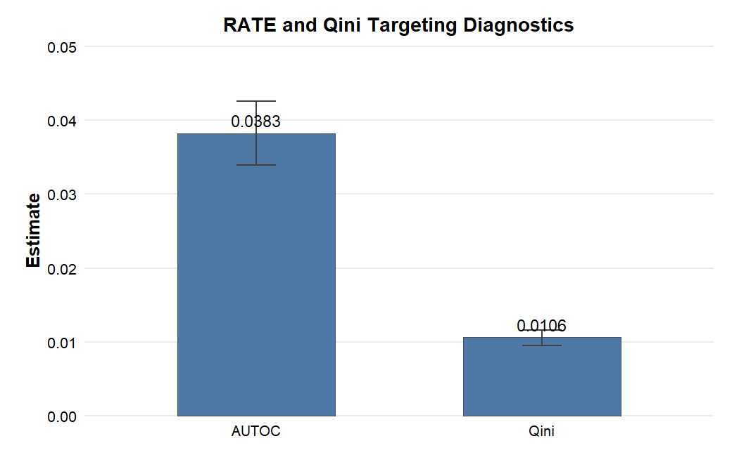Figure 5.9. RATE and Qini targeting diagnostics
Source: Calculation from causal forest RATE/Qini diagnostics.
This figure summarizes the RATE and Qini diagnostics. Positive values support the conclusion that the CATE ranking contains targeting information rather than only random heterogeneity.
The positive and significant RATE/Qini results suggest that customers ranked higher by estimated CATE tend to have larger incremental response gains. This supports the use of causal forest for targeting-oriented interpretation.

5.6.2. Mean CATE by customer decile
Among customers originally assigned to channel 124, customers are ranked by estimated CATE and divided into deciles. Higher deciles represent customers with larger predicted incremental response if assigned to channel 26.
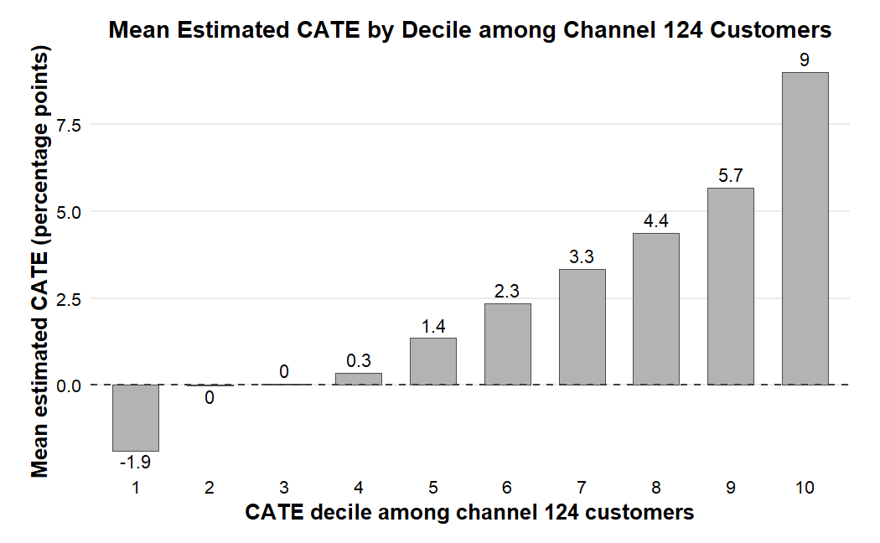Figure 5.10. Mean estimated CATE by decile among channel 124 customers
Source: Calculation from causal forest.
The decile plot shows a clear increasing pattern. The highest decile has a mean CATE of approximately 10.1 percentage points. This means that, under the observed adjustment strategy and identification assumptions of the study, customers in this segment are predicted to gain the most from assignment to channel 26.

5.6.3. Top 10% predicted-gain customer profile
The top 10% predicted-gain group among channel 124 customers contains approximately 7,400 customers. Their average estimated CATE is about 10.1 percentage points, implying approximately 750 expected incremental responses if these customers were assigned to channel 26 rather than channel 124.
A striking feature of the top 10% predicted-gain profile is that 100.0% of these customers have a history of vehicle damage, compared to only 64.3% in the rest of the channel 124 sample (Figure 5.11). From a behavioral perspective, this is a highly logical business insight. Customers who have experienced vehicle damage are inherently more risk-aware and have a latent demand for protection. However, this latent demand might not easily convert into a purchase under standard approaches (e.g., channel 124). The CATE estimate suggests that assigning this specific, risk-aware segment to channel 26—which may offer better consultation, trust, or persuasion—effectively triggers their latent demand, resulting in a substantial 10.1 percentage point incremental gain.
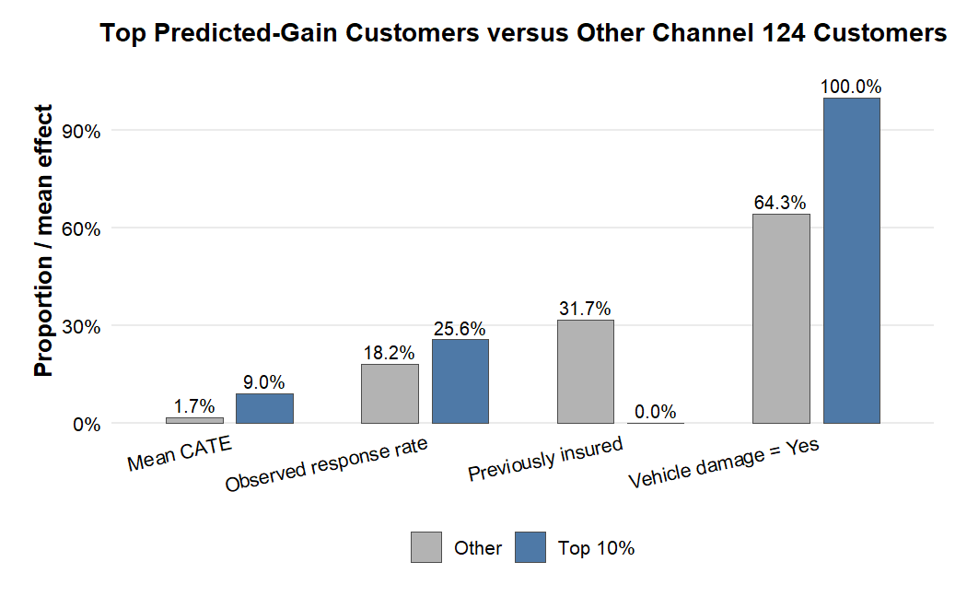
Figure 5.11. Top 10% predicted-gain customers versus other channel 124 customers
Source: Calculation from causal forest.

5.7. Discussion

5.7.1. Research Question 1: Average Treatment Effect
The first research question asks whether assignment to channel 26 rather than channel 124 affects customer response after adjusting for observed pre-treatment covariates. The main AIPW estimate indicates that assignment to channel 26 increases customer response probability by approximately 2.64 percentage points relative to channel 124. This estimate is larger than the raw response-rate difference of about 1.03 percentage points, suggesting that the unadjusted comparison does not fully capture differences in customer composition across the two channel groups.
One possible interpretation is that some observed characteristics of customers in channel 26 suppress the raw comparison. After adjusting for gender, age, region, previous insurance status, vehicle characteristics, log annual premium and vintage, the estimated channel effect becomes larger. Therefore, the AIPW result provides the main evidence that channel 26 is associated with a positive incremental response effect within the observed adjustment strategy.
At the same time, this result should not be interpreted as equivalent to a randomized experiment. The dataset does not reveal the full business logic behind channel assignment, so unobserved factors may still affect both channel allocation and response.

5.7.2. Research Question 2: Robustness across estimators
The second research question asks whether the estimated effects are consistent across methods and diagnostics. The robustness results are generally consistent with the main finding, although the size of the effect differs across estimators. IPW and causal forest produce positive estimates that are close to the AIPW estimate. This consistency supports the direction of the main result.
The PSM estimate is smaller, at about 0.69 percentage points. This difference is not necessarily a contradiction because PSM mainly estimates the ATT, while AIPW estimates the ATE for the full analysis sample. In other words, PSM focuses on customers who were already assigned to channel 26, whereas AIPW considers the average effect across both channel groups. The smaller ATT may suggest that customers already in channel 26 have less additional room for improvement, while some customers in channel 124 may have larger potential gains if assigned to channel 26.
The diagnostic checks also support the stability of the empirical pipeline. The trimmed AIPW estimate is close to the full-sample AIPW estimate, suggesting that weak-overlap observations do not drive the main result. Furthermore, the negative-control outcome estimate for gender is close to zero and statistically insignificant. This is reassuring because gender should not be affected by sales channel assignment. The permutation-based pipeline sanity check further shows that the estimation procedure does not mechanically generate a positive effect when treatment labels are randomized. These checks do not eliminate all concerns about unobserved confounding, but they reduce the likelihood that the main result is only an artifact of the estimation process.

5.7.3. Research Question 3: Value of heterogeneity-based targeting
The third research question asks whether treatment effect heterogeneity can support targeting analysis. The causal forest results, supported by calibration tests and RATE/Qini diagnostics, confirm that the estimated effect of channel 26 is not evenly distributed across customers. Many customers have treatment effects close to zero, while a smaller group has substantially higher predicted gains.
This finding is important because it shifts the managerial interpretation from a broad channel comparison to a targeted allocation problem. Specifically, the top 10% predicted-gain decile among channel 124 customers has an average estimated CATE of approximately 10.1 percentage points (around 750 expected incremental responses). This suggests that the main value of causal forest lies in identifying high-potential customer segments rather than applying the same channel strategy to all customers.

5.7.4. Limitations and hidden confounding
The results must be interpreted with caution due to several remaining limitations. First, the analysis is based on observational data. While the DAG-based checks clarify the adjustment logic, unobserved factors such as lead quality, campaign intensity, or latent customer intention may still affect both channel assignment and response.
Second, the channel variables are coded without exact business descriptions or cost structures. Therefore, the analysis can compare channels statistically, but it cannot determine operational differences. Furthermore, the outcome is customer response rather than profit; a higher response probability does not automatically imply higher profitability if channel 26 is significantly more expensive to operate.
Finally, the causal forest targeting results are best interpreted as exploratory guidelines under the selection-on-observables framework. A randomized campaign or A/B test would be needed before turning these CATE rankings into a definitive operational policy.

CHAPTER 6. CONCLUSION

6.1. Summary of Main Findings
This thesis studies the effect of policy sales channel assignment on customer response in an insurance cross-selling setting. The analysis focuses on customers assigned to channel 26 and channel 124 in the Health Insurance Cross Sell dataset. Channel 26 is treated as the treatment group, while channel 124 is treated as the control group.
The main result is that channel 26 is associated with a higher response probability than channel 124 after adjusting for observed pre-treatment covariates. The AIPW estimate, which is the main estimate of the thesis, is approximately 2.64 percentage points. IPW and causal forest estimates are close to the AIPW estimate, while PSM provides a smaller but still positive ATT-based comparison.
Robustness and diagnostic checks support the empirical pipeline. The trimmed AIPW result is close to the full-sample result. The negative-control outcome diagnostic using gender produces an insignificant effect close to zero. The permutation-based pipeline sanity check shows that the true estimate is far from the distribution obtained when treatment labels are randomly permuted.

6.2. Managerial Implications
The findings suggest that insurance firms should not rely only on predicted response probability when allocating sales channels. A customer with a high predicted response may respond regardless of the channel used. From a managerial perspective, the more relevant question is which channel creates additional response.
The average treatment effect results suggest that channel 26 may be more effective than channel 124 on average, under the identification assumptions of the study. However, the heterogeneity results show that the effect is not uniform across all customers. Some customers are predicted to benefit much more from channel 26 than others.
This has practical implications for channel allocation, but the recommendation should be interpreted conditionally because the dataset provides coded channel identifiers rather than the business nature or cost structure of each channelFirms may use estimated CATE scores to prioritize customers who are expected to gain the most from assignment to channel 26. In practice, optimal channel allocation should maximize the marketing Return on Investment (ROI). This is achieved by strategically targeting high-CATE customers whose expected incremental revenue from the vehicle insurance policy strictly exceeds the marginal cost difference between operating channel 26 and channel 124.
A further implication is that causal analysis can complement, rather than replace, predictive modeling. Predictive models remain useful for identifying customers likely to respond, while causal analysis focuses on whether the channel decision itself is associated with incremental response. If channel 26 is low-cost or similar in cost to channel 124, the positive estimated effect supports broader use. If channel 26 is high-cost, the recommendation should be limited to high-CATE customers whose expected incremental benefit is more likely to exceed the additional cost.

6.3. Limitations
This thesis has several limitations. First, the dataset is observational. Customers were not randomly assigned to channel 26 or channel 124. Therefore, the causal interpretation relies on the selection-on-observables assumption.
Second, the public dataset does not provide detailed business descriptions or cost information for the policy sales channel codes. As a result, channel 26 and channel 124 are treated as coded channel categories rather than named business channels, and managerial recommendations must be interpreted conditionally on the unknown channel cost structure.
Third, the DAG is formally checked using dagitty, but this check only supports that the adjustment set blocks observed back-door paths under the Observable DAG. It does not prove that the DAG is the true data-generating process. Hidden confounding may still remain.

6.4. Future Research Directions
Future research can extend this thesis in several directions. First, randomized experiments or A/B tests would provide stronger evidence on sales channel effectiveness. Second, firm-level data with detailed business descriptions of each channel would allow more meaningful managerial interpretation. Third, future studies can extend the binary treatment setting to a multi-channel treatment framework. Fourth, future research can examine profit-based outcomes instead of response alone.
Despite these limitations, the thesis shows how causal inference can improve the evaluation of insurance cross-selling strategies. By combining average treatment effect estimation, robustness diagnostics, and heterogeneous treatment effect analysis, the study provides a structured framework for moving from response prediction to intervention-oriented channel allocation.
The findings also suggest a more general lesson for insurance analytics. When firms evaluate marketing actions using observational data, they should avoid relying only on predictive scores or raw conversion rates. A structured causal design can help clarify whether a marketing action is associated with incremental response. Even when causal certainty is not possible, transparent assumptions, diagnostics and robustness checks can make the analysis more informative for decision-making.

REFERENCES
Athey, S. and Imbens, G. W. (2016), ‘Recursive partitioning for heterogeneous causal effects’, Proceedings of the National Academy of Sciences, 113(27), pp. 7353-7360.
Pearl, J. and Mackenzie, D. (2018), The Book of Why: The New Science of Cause and Effect, Basic Books, New York.
Molak, A. (2023), Causal Inference and Discovery in Python: Machine Learning and Pearlian Perspective, Packt Publishing, Birmingham.
Athey, S., Tibshirani, J. and Wager, S. (2019), ‘Generalized random forests’, The Annals of Statistics, 47(2), pp. 1148-1178.
Austin, P. C. (2011), ‘An introduction to propensity score methods for reducing the effects of confounding in observational studies’, Multivariate Behavioral Research, 46(3), pp. 399-424.
Breiman, L. (2001), ‘Random forests’, Machine Learning, 45(1), pp. 5-32.
Hernan, M. A. and Robins, J. M. (2020), Causal Inference: What If, Chapman & Hall/CRC, Boca Raton.
Imbens, G. W. and Rubin, D. B. (2015), Causal Inference for Statistics, Social, and Biomedical Sciences: An Introduction, Cambridge University Press, Cambridge.
Pearl, J. (2009), Causality: Models, Reasoning and Inference, 2nd edn, Cambridge University Press, Cambridge.
Rosenbaum, P. R. and Rubin, D. B. (1983), ‘The central role of the propensity score in observational studies for causal effects’, Biometrika, 70(1), pp. 41-55.
Robins, J. M., Rotnitzky, A. and Zhao, L. P. (1994), ‘Estimation of regression coefficients when some regressors are not always observed’, Journal of the American Statistical Association, 89(427), pp. 846-866.
Wager, S. and Athey, S. (2018), ‘Estimation and inference of heterogeneous treatment effects using random forests’, Journal of the American Statistical Association, 113(523), pp. 1228-1242.
Kaggle (2020), Health Insurance Cross Sell Prediction, Kaggle dataset, available at: https://www.kaggle.com/datasets/anmolkumar/health-insurance-cross-sell-prediction (Accessed: 28 April 2026).

APPENDICES

Appendix A. Suggested figures to insert from R
Figure | Description
Figure 3.1 | Response distribution in the original dataset
Figure 3.2 | Top policy sales channels by sample size
Figure 3.3 | Response rate across major policy sales channels
Figure 3.7 | Observable and conceptual DAG with latent U
Figure 5.2 | Propensity score overlap plot
Figure 5.6 | Permutation-based pipeline sanity check
Figure 5.7 | Zoomed CATE distribution
Figure 5.10 | Mean CATE by decile among channel 124 customers

Appendix B. Notes on interpretation
All empirical results should be interpreted under the DAG-based identification assumptions and the selection-on-observables framework. The estimates are not equivalent to randomized experimental estimates because policy sales channel assignment is not randomly assigned in the dataset. Negative-control and permutation-based checks are used as diagnostics, not as proof that hidden confounding is absent.

